(a)

200 .- .-,-.,-r-r-. -.-,-,.-.-

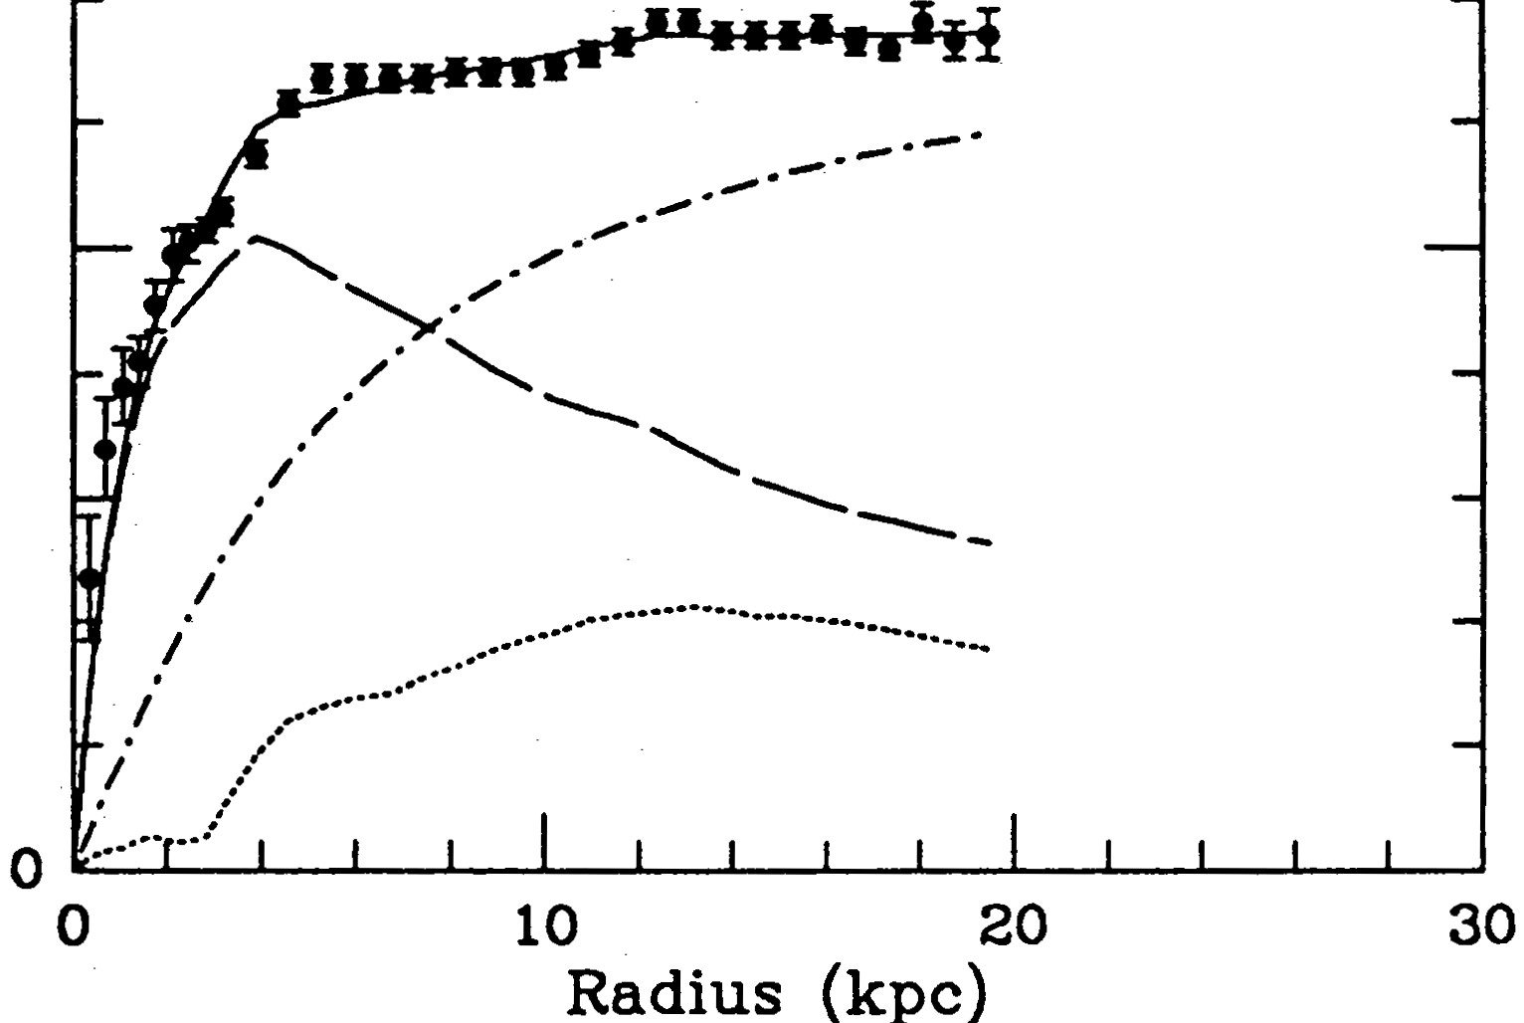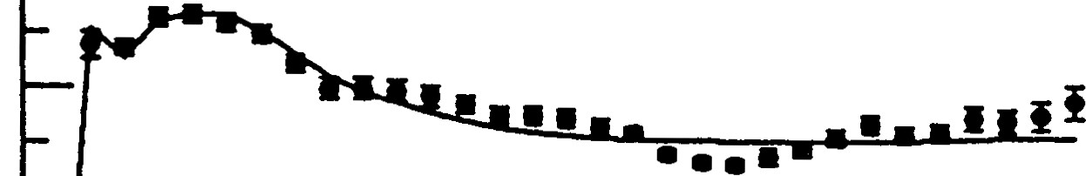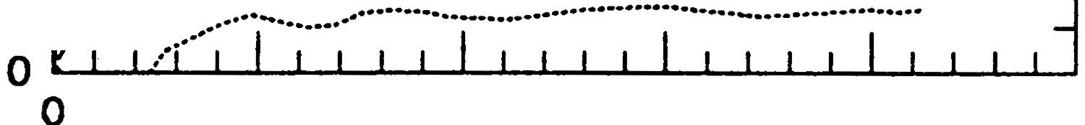

Irn

NGC 2403

300

i

rn

NGC 2841

('"x _------ --·-··

cEl 100

>.0!o

cEl 200

.!o

>

100

*11* \'x.*./·* "''---........... _

--------

/ ...........

,/ '-..

_,·

---

·' ------

*1*

*I*

10 20 30

Radius (kpc)

40 50

300

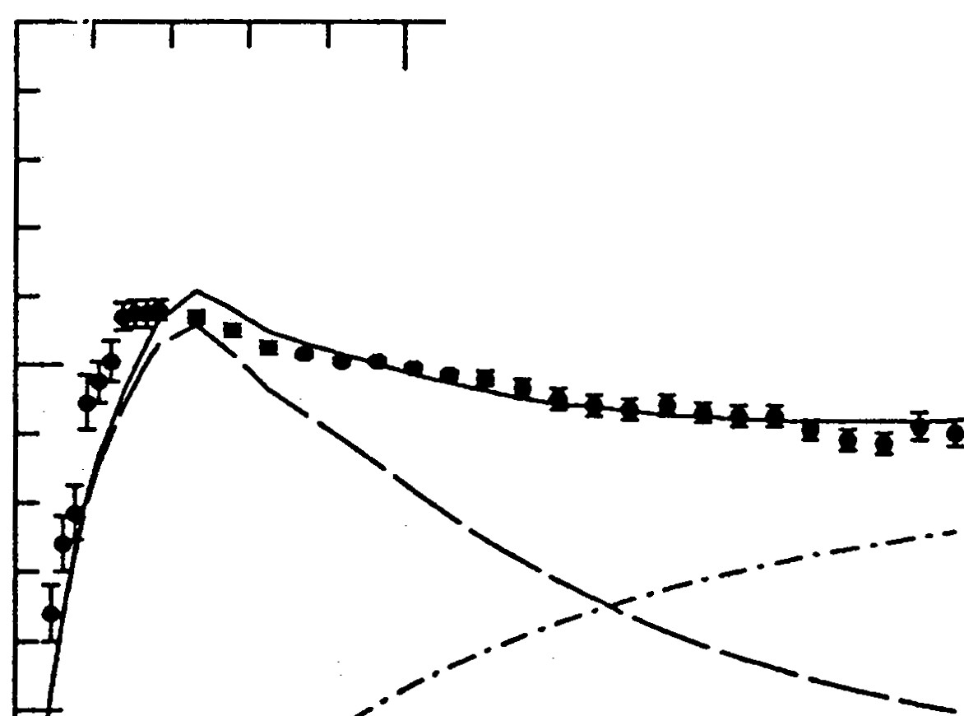

NGC 2903

NGC 3198

i

rn

cEl

200

i

*,*"*g*'

100 ;

/

.---.-·­

>-ll

/

*/*

100 *i*

;

*/ I*

/ *I*

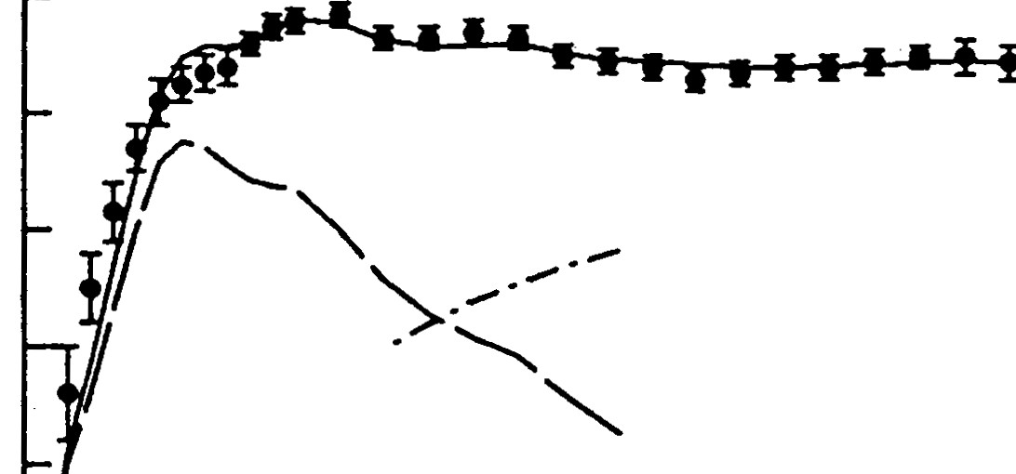

*/ i* ......................................................

*/*

/./· ····-............•....... -····-··· ····· ··························

0 */* ..·····

0 10

Radius (kpc)

NGC 6503

,' *../ ············*

30 10 20 30 40

Radius (kpc)

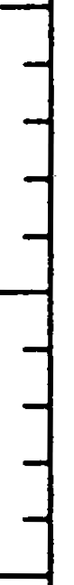

NGC 7331

i

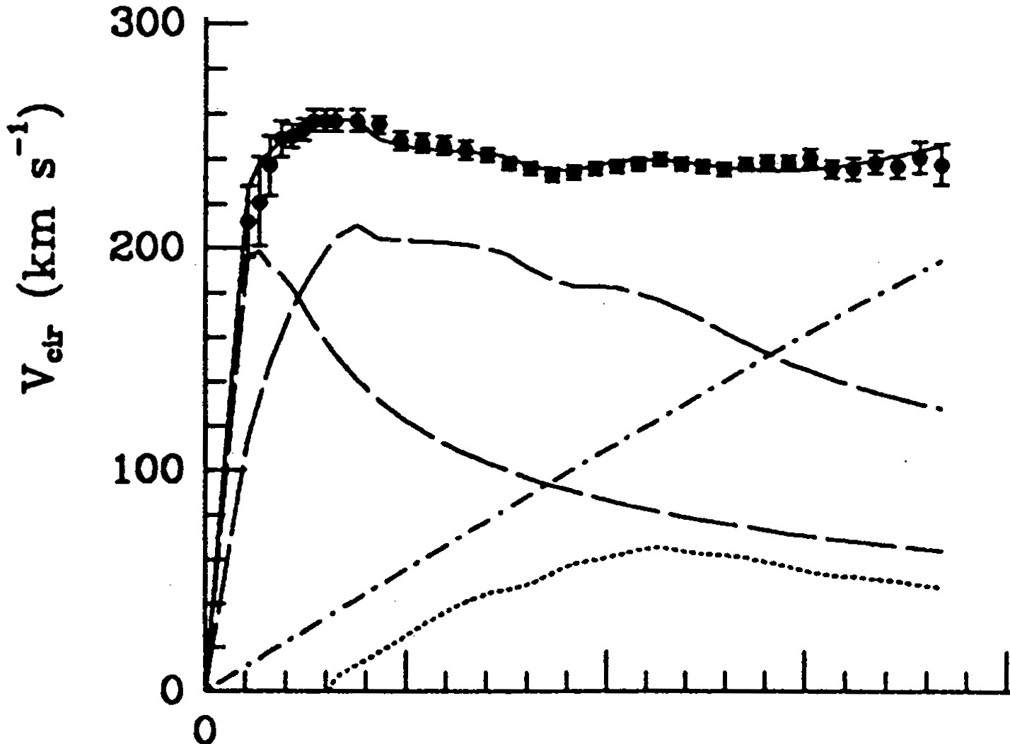

rn

] 100 -

-" *V""'\_ /* ---·-·

*/·'<.,_'-..*

-----

-·-·-·-··

*i/* ...................... _

;

b -----·-···········-····-···--·········-········-··········-.

0 10 20

Radius (kpc)

30 10 20 30

Radius (kpc)

40 50